Contents

Webpage images: 1

Index background video 10

Favicon 10

# Webpage images:

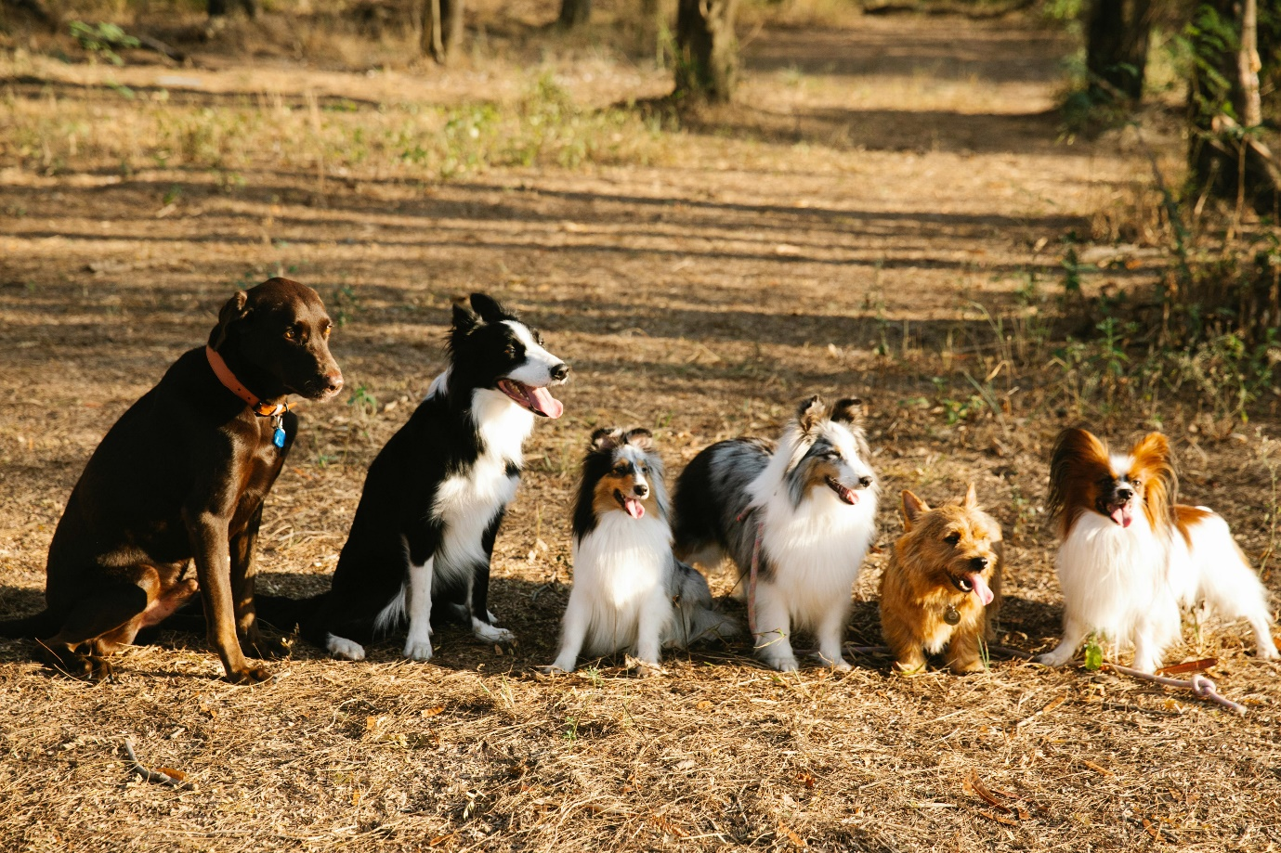

(Pexels, 2000) 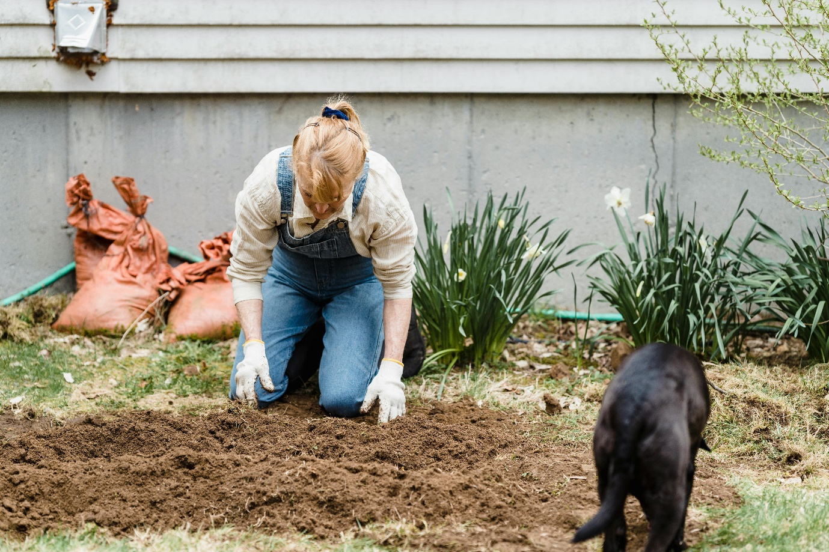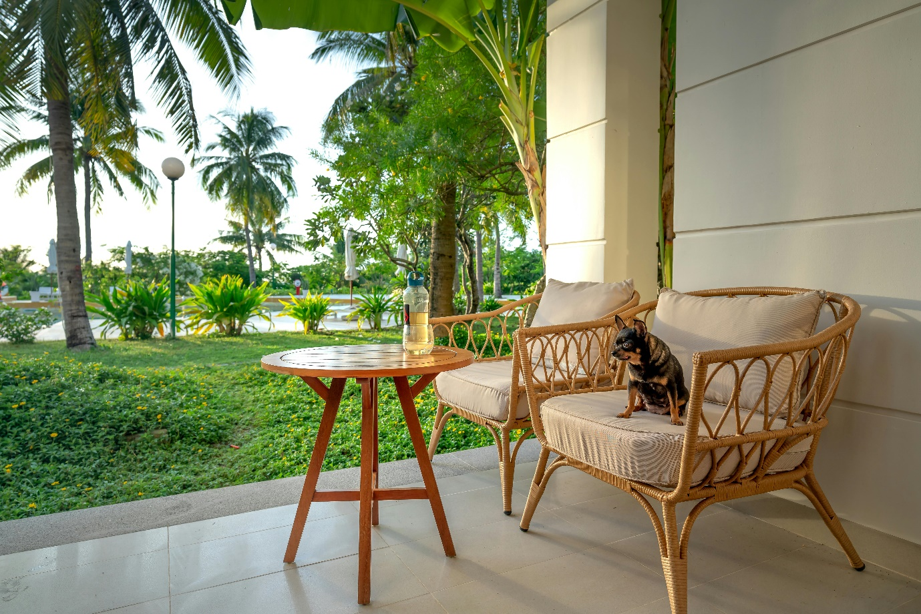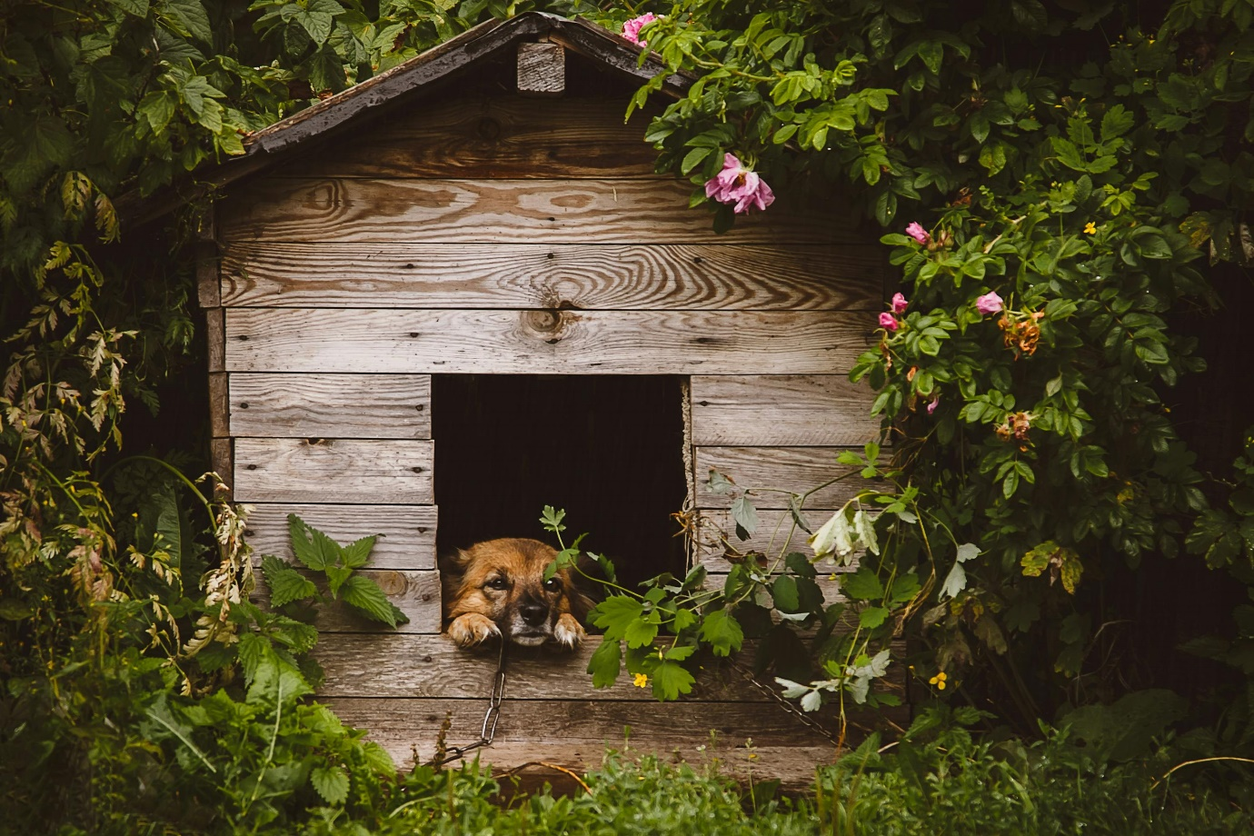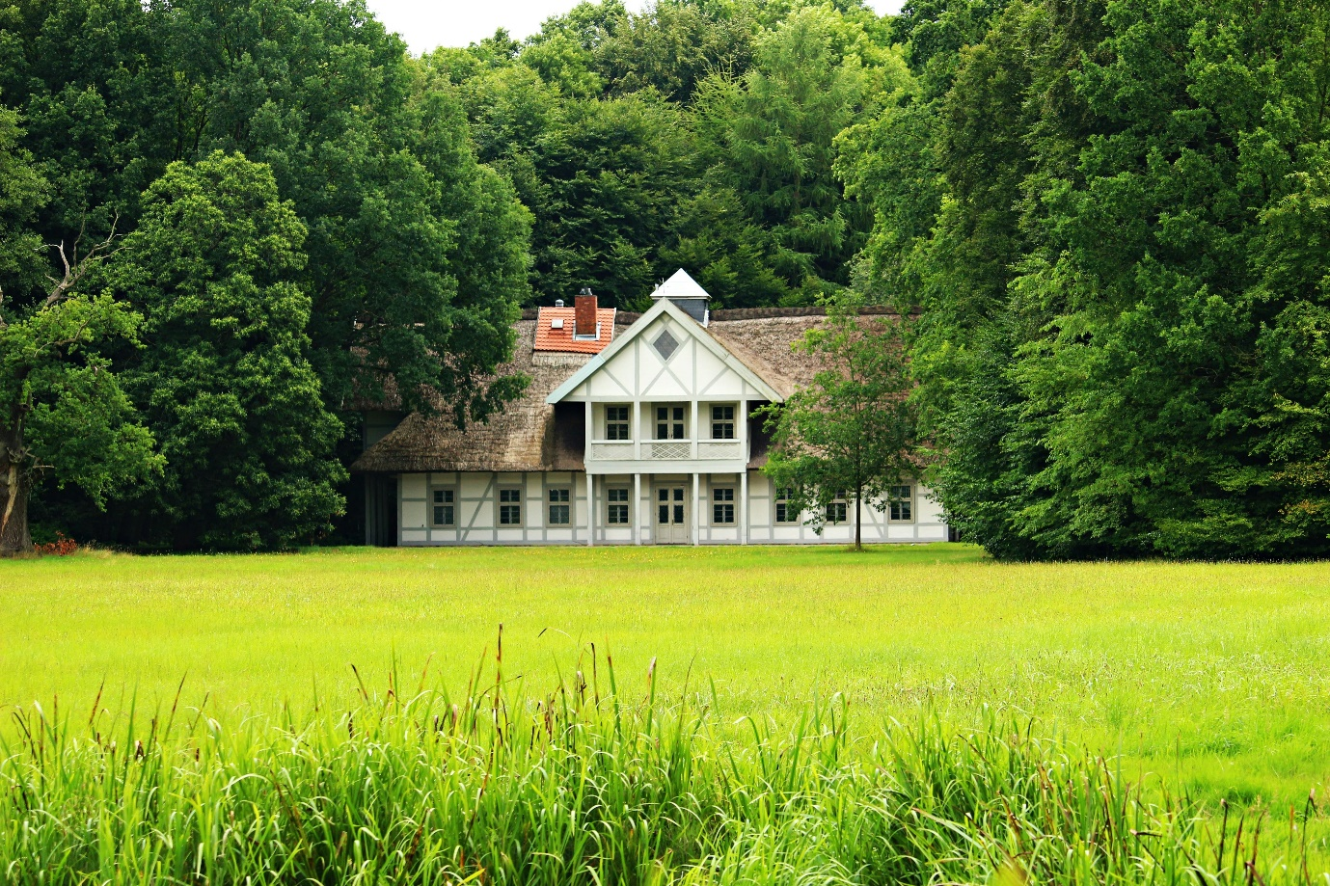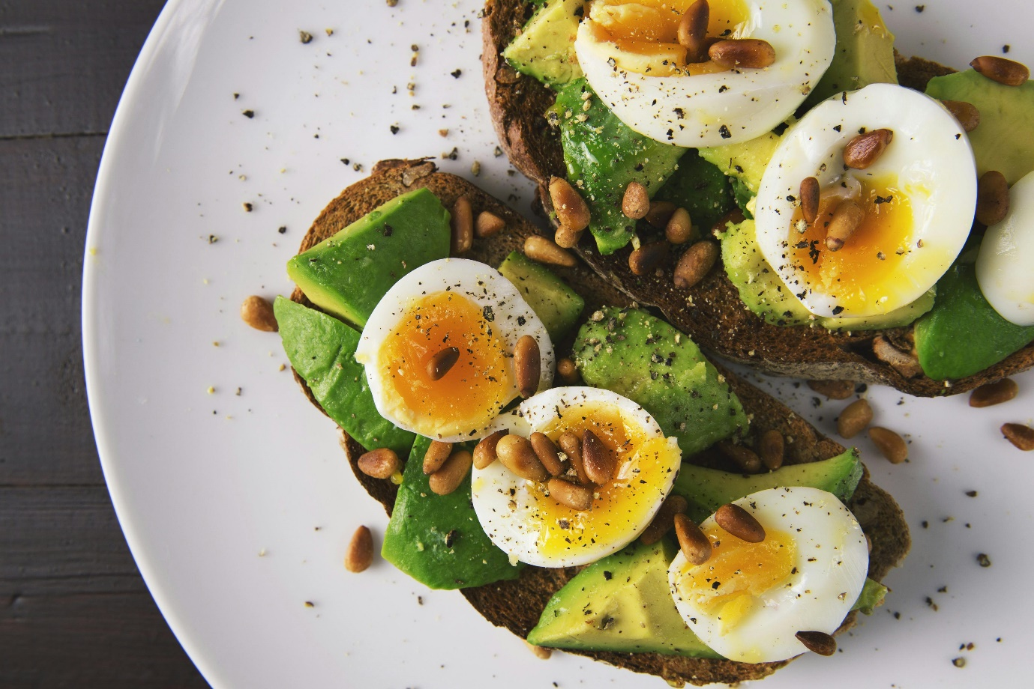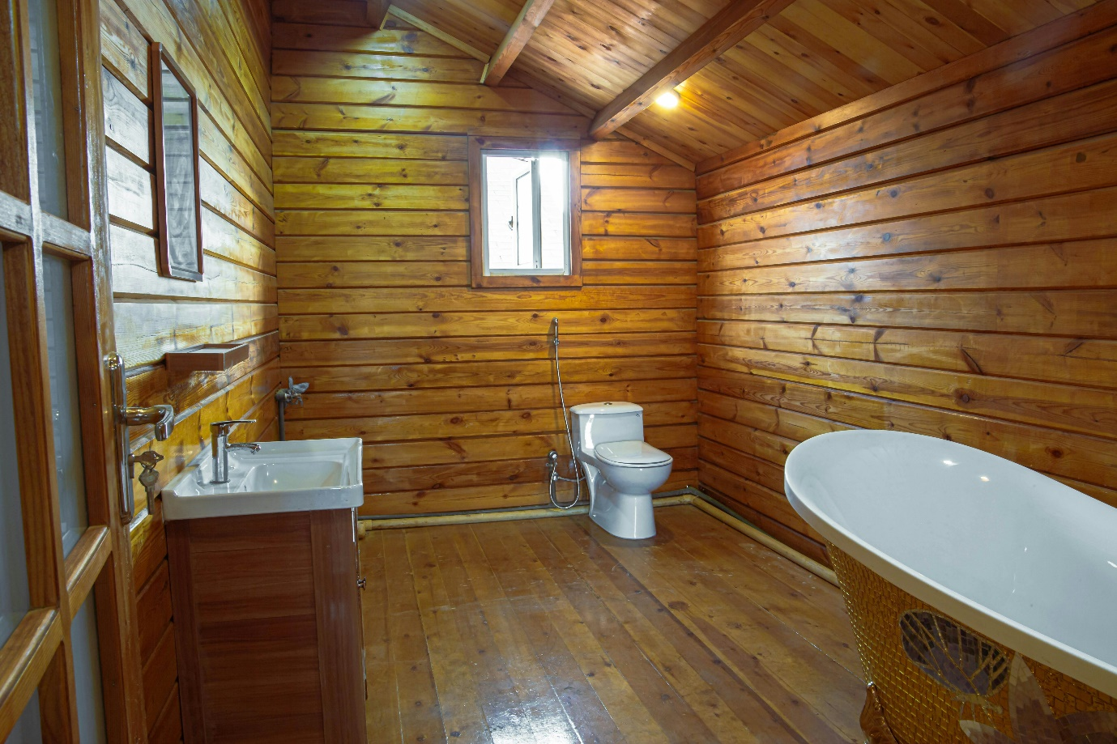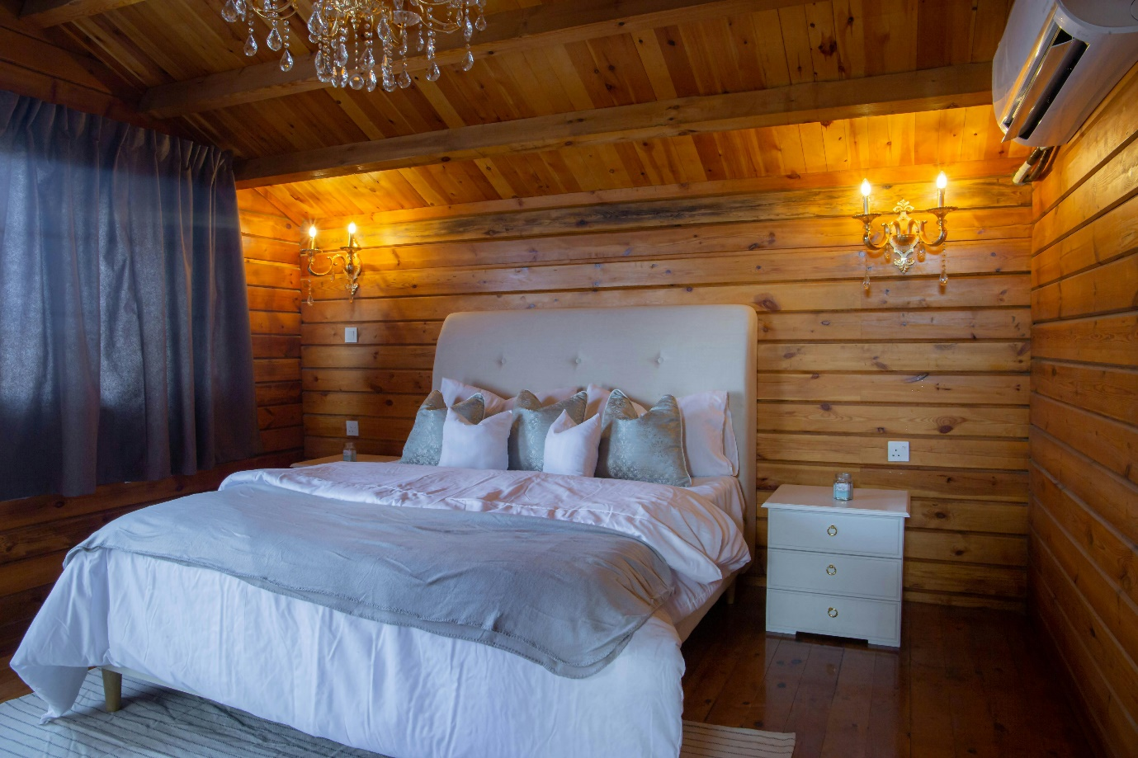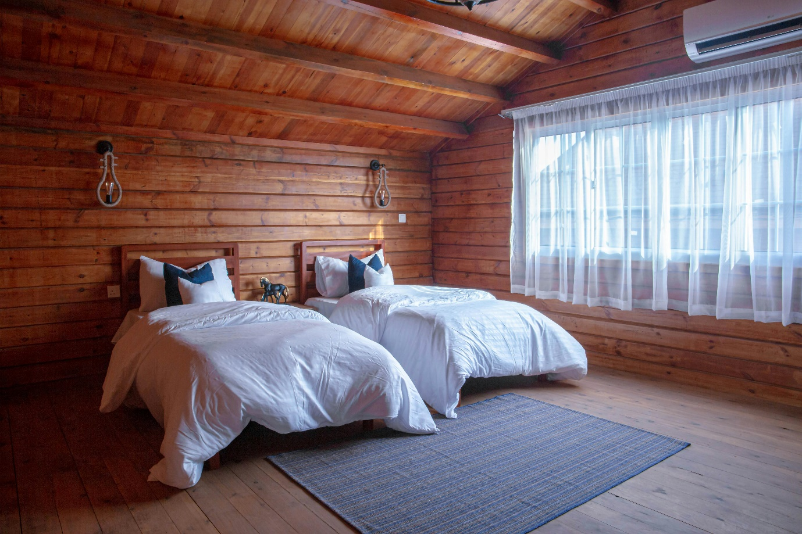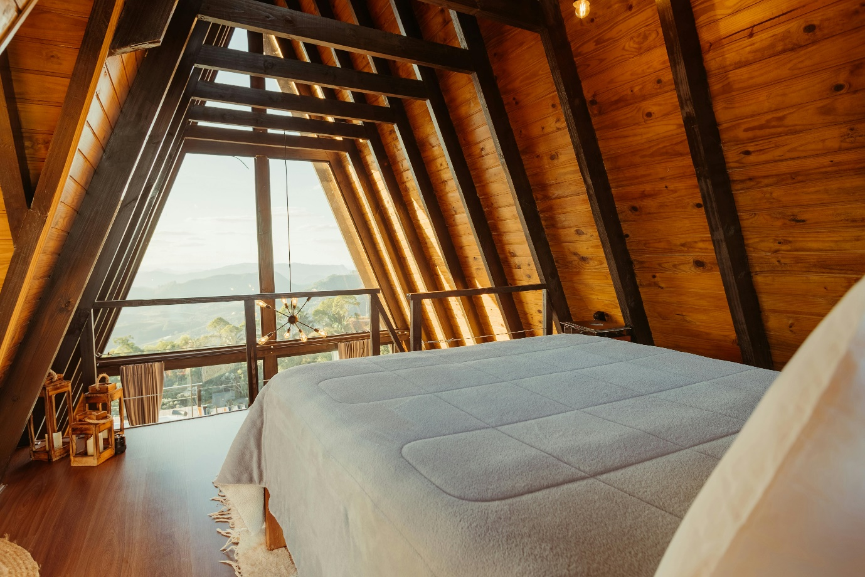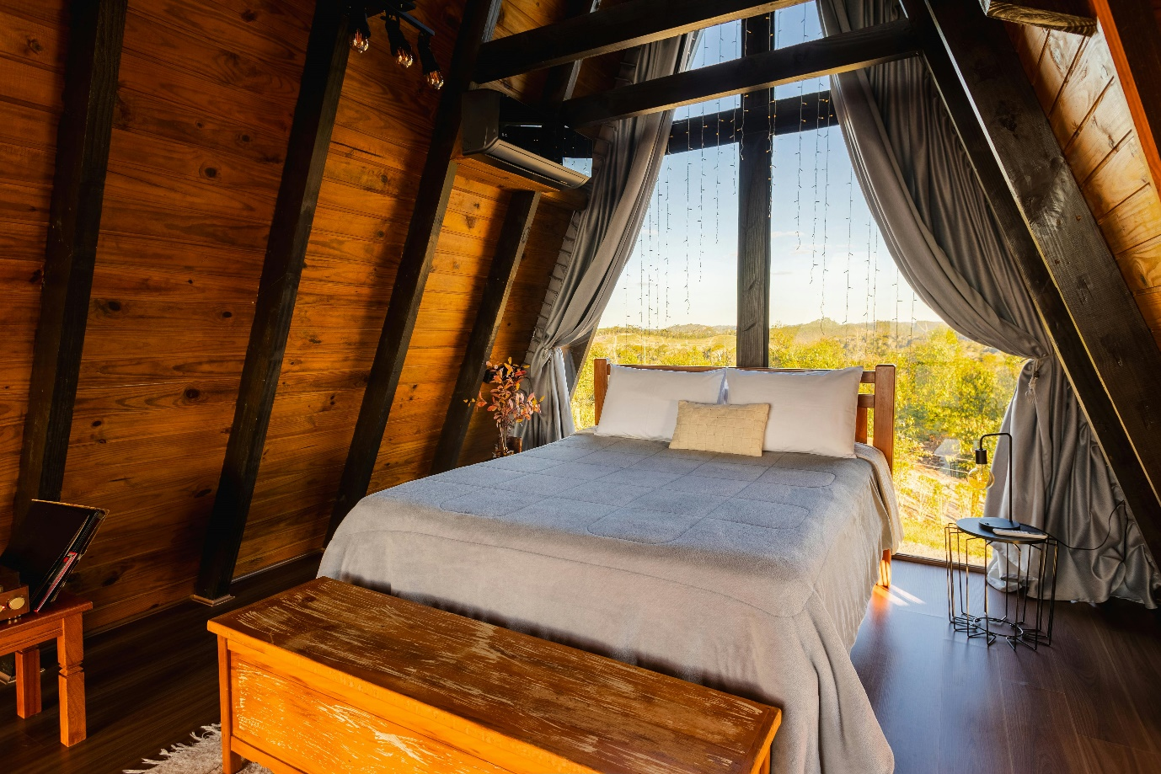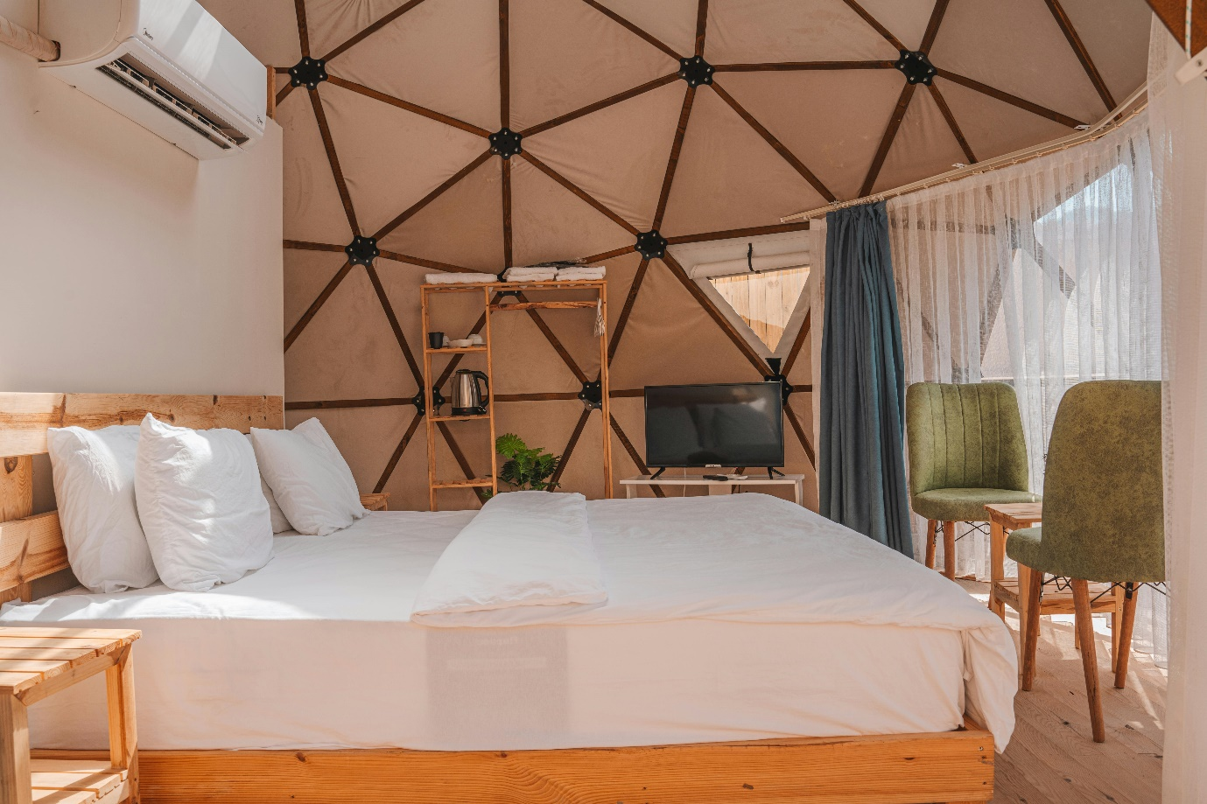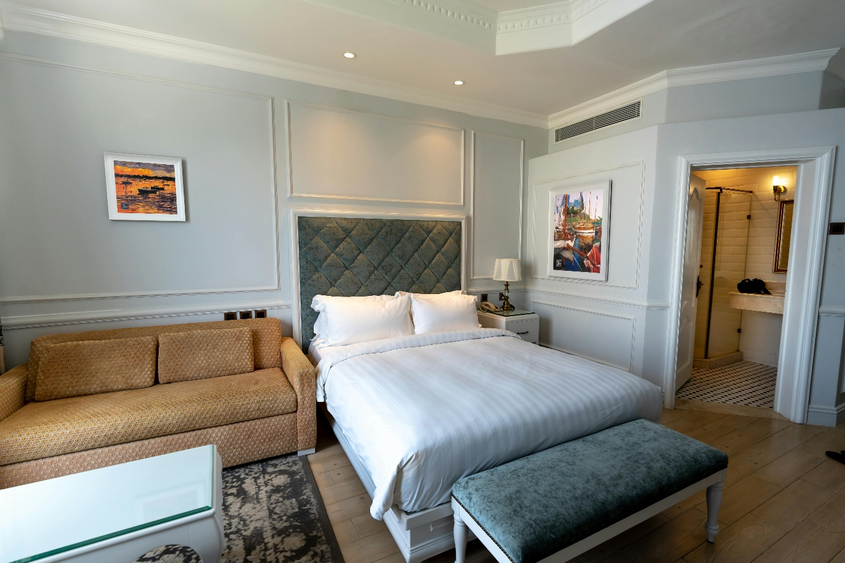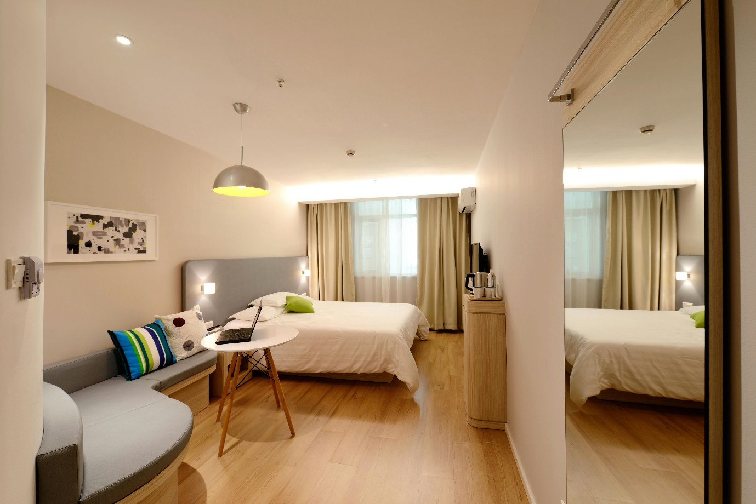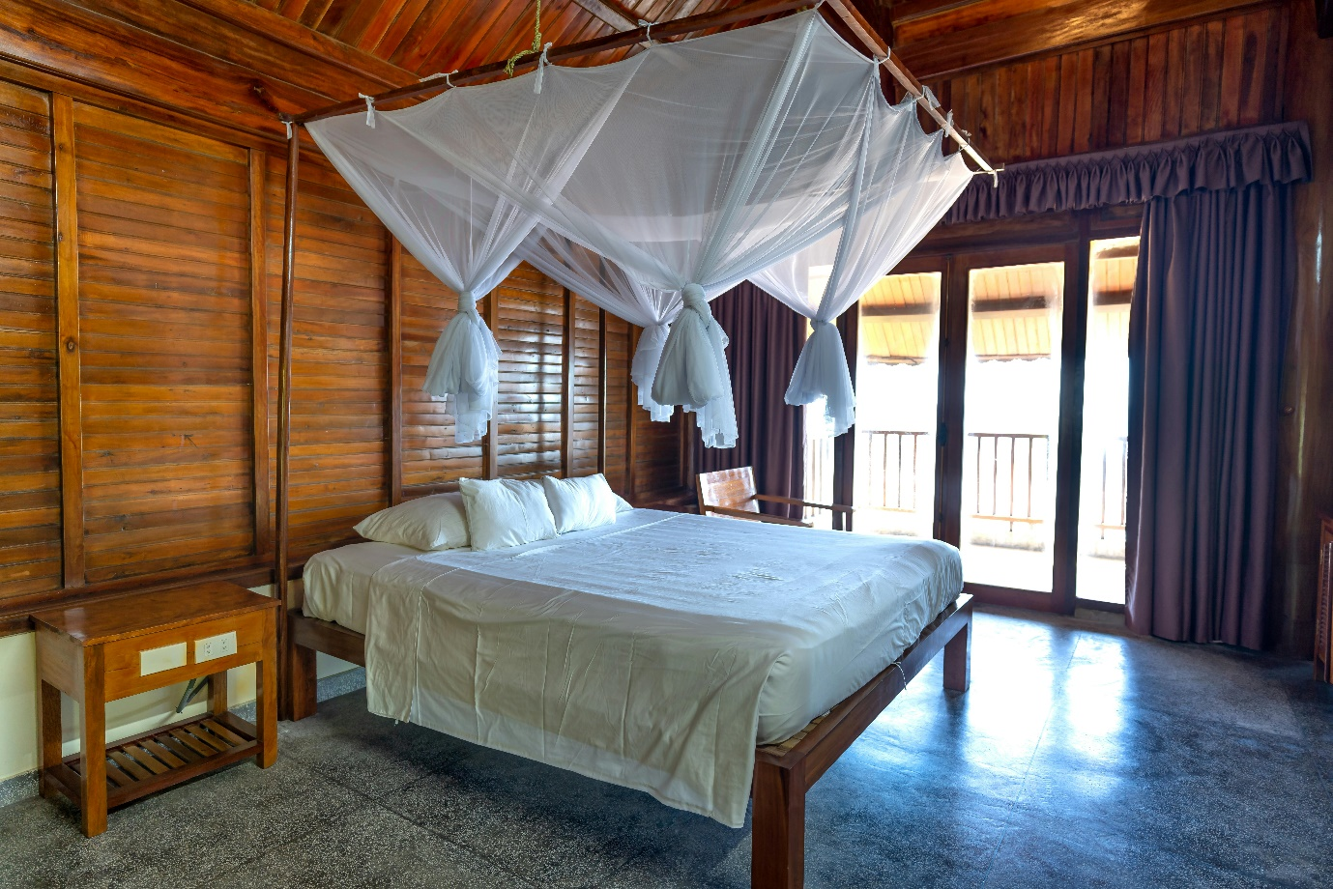

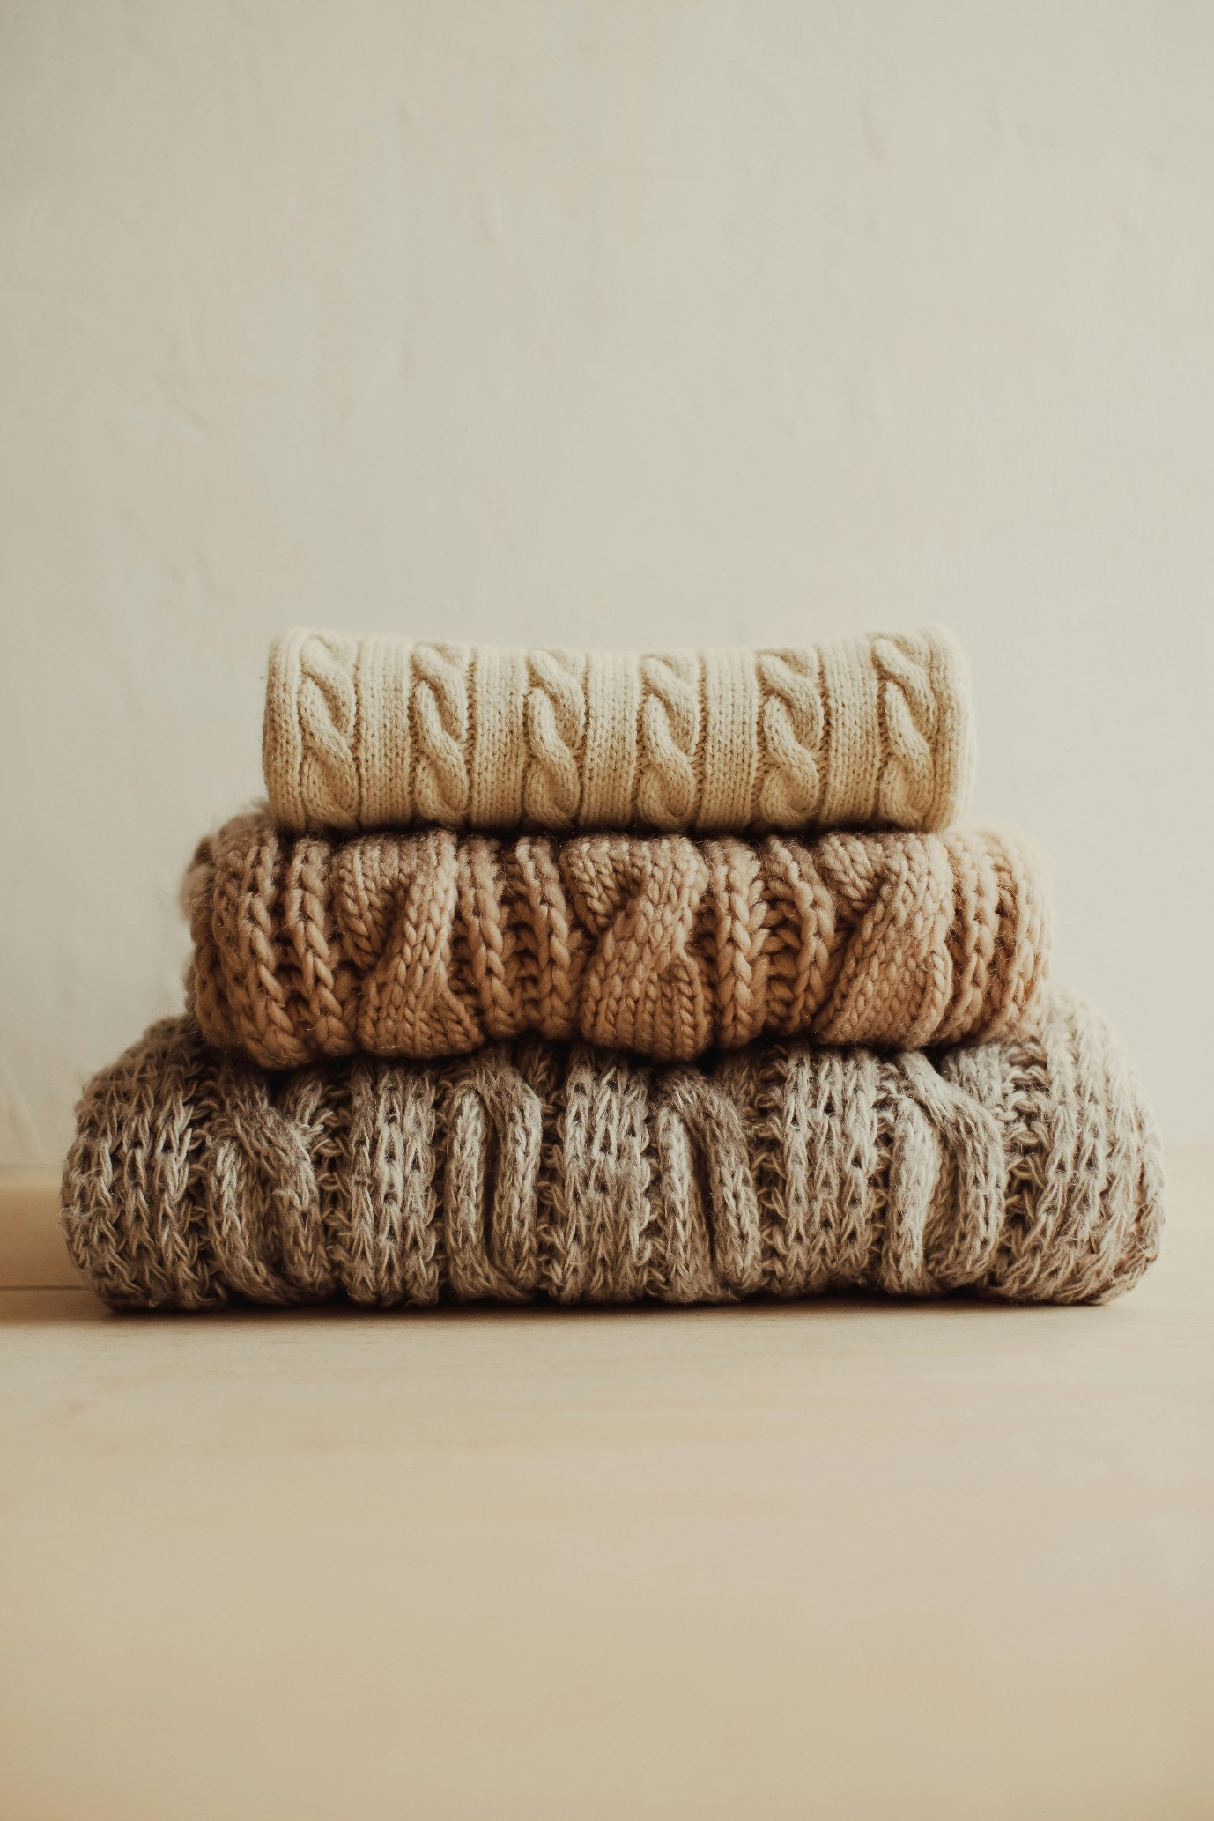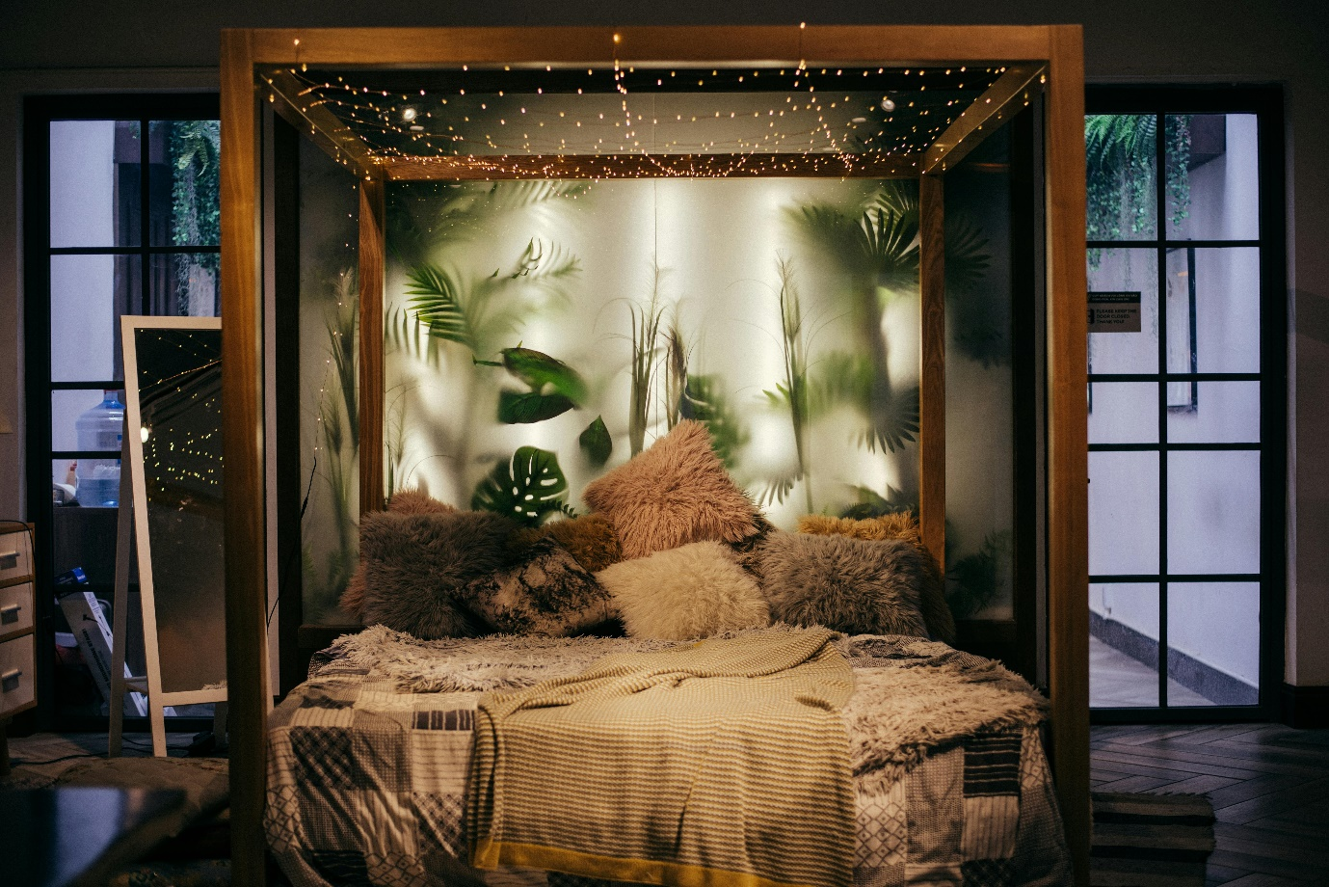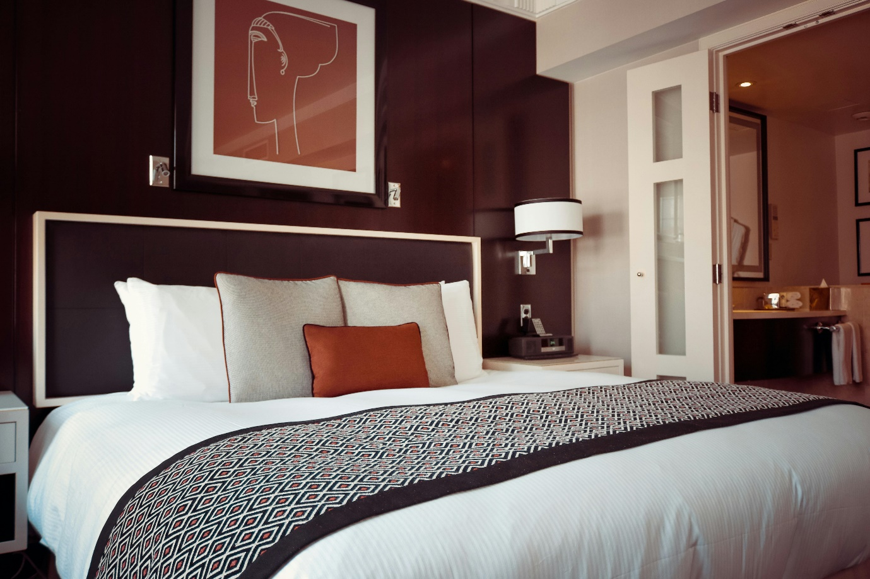 (Pexels, 2000)

# Index background video (Adventure, n.d.)

[www.aranislands.ie](http://www.aranislands.ie)

discover Ireland

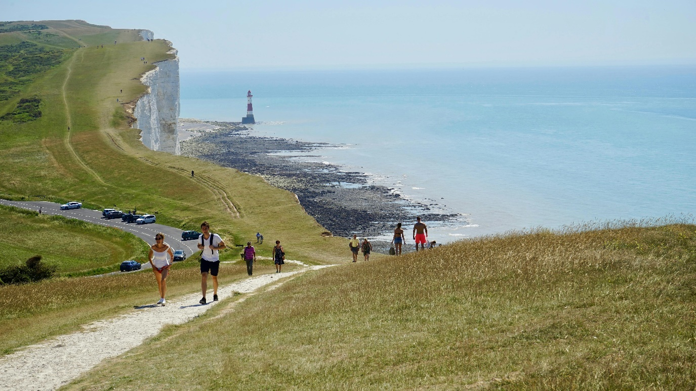

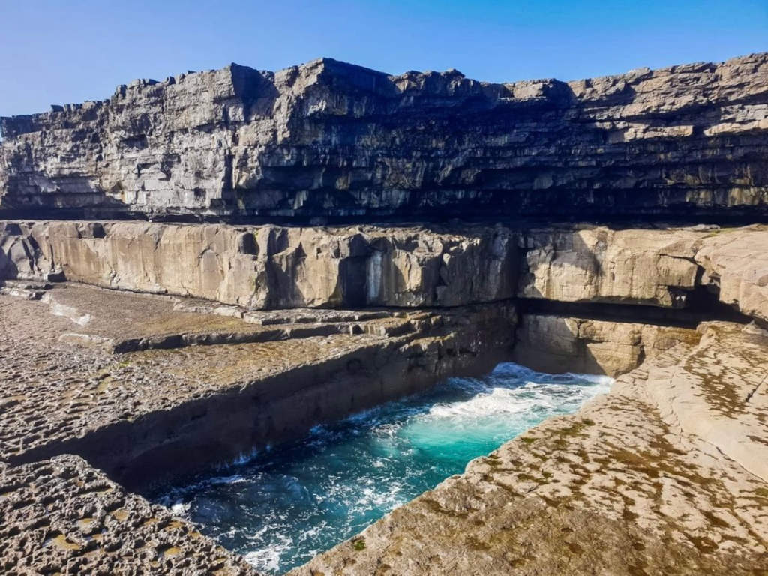 (Trip, n.d.)

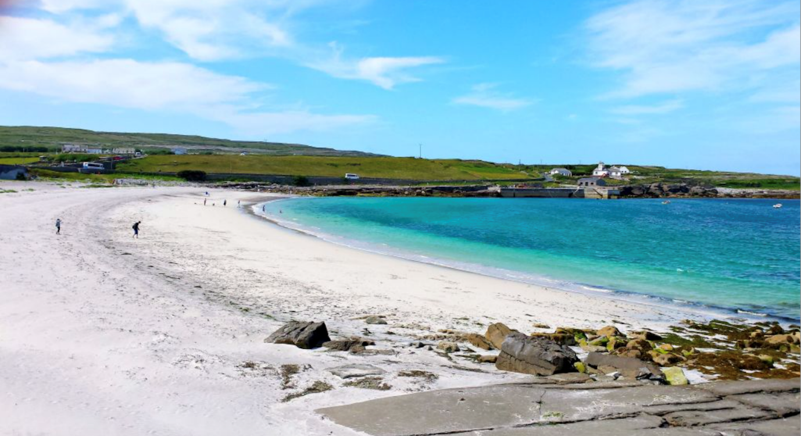

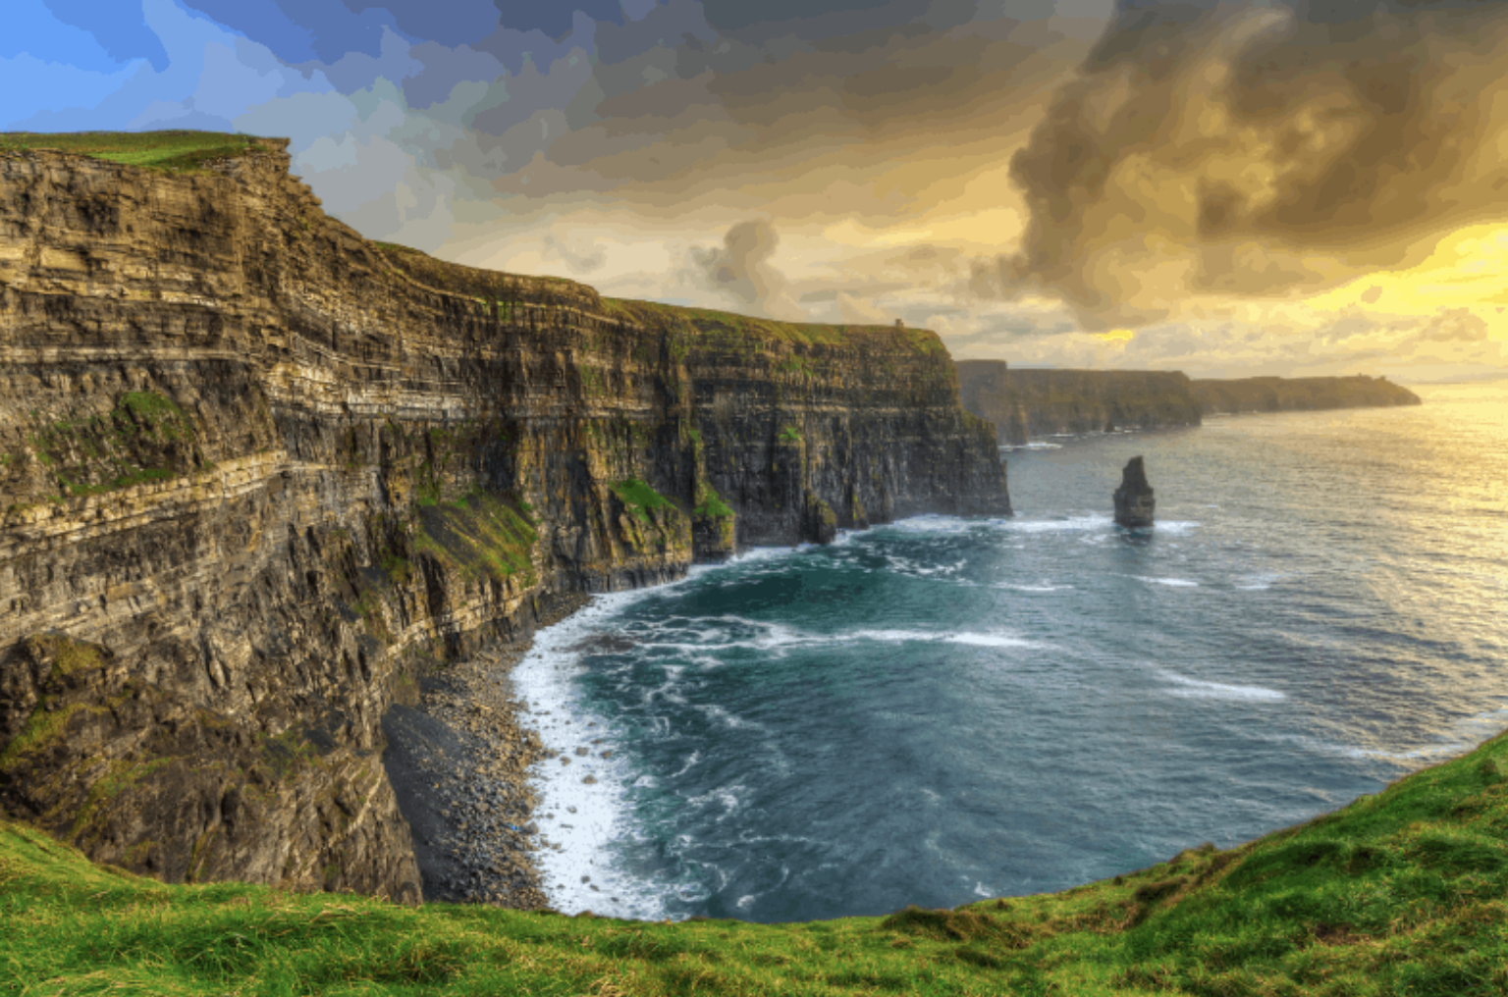

(Nicole, n.d.)

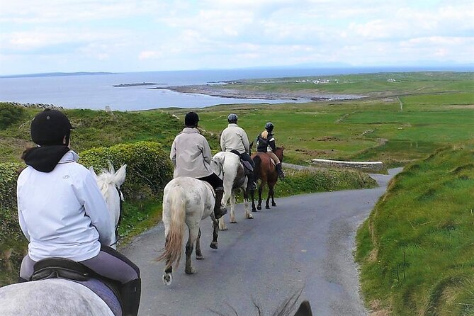 (Ireland, n.d.)

# (Academy, n.d.)

# Website Logo

# 

# (CANVA , n.d.)

# Favicon

 (FREEPIK, n.d.)

# References

Academy, D. (n.d.). Retrieved from https://www.diveacademy.info/

Adventure, N. (n.d.). Retrieved from https://www.youtube.com/watch?v=xUraiv6ENC8

*CANVA* . (n.d.). Retrieved from https://www.canva.com/photo-editor/?utm_source=google_sem&utm_medium=cpc&utm_campaign=uk_en_all_payback-generic_photo-editor_lower_rev_roas_bm&utm_adgroup=uk_en_all_payback-generic_photo-editing-software_lower_rev_roas_bm&utm_keyword=editing+software+for+

*FREEPIK*. (n.d.). Retrieved from https://www.freepik.com/free-photos-vectors/logo

Ireland, R. t. (n.d.). Retrieved from https://relocatingtoireland.com/exploring-irelands-aran-islands-a-complete-guide/

Nicole. (n.d.). *GO FAR GROW CLOSE*. Retrieved from https://gofargrowclose.com/aran-islands-inis-oirr-cliffs-moher/

Pexels. (2000, 04 24). *Pexels*. Retrieved from Pexels: https://www.pexels.com/search/photoshop/

Trip, I. R. (n.d.). Retrieved from https://www.theirishroadtrip.com/the-wormhole-inis-mor/